

CSW-HD201C
2x1/1x2 HDMI 4K Switcher with Pigtail
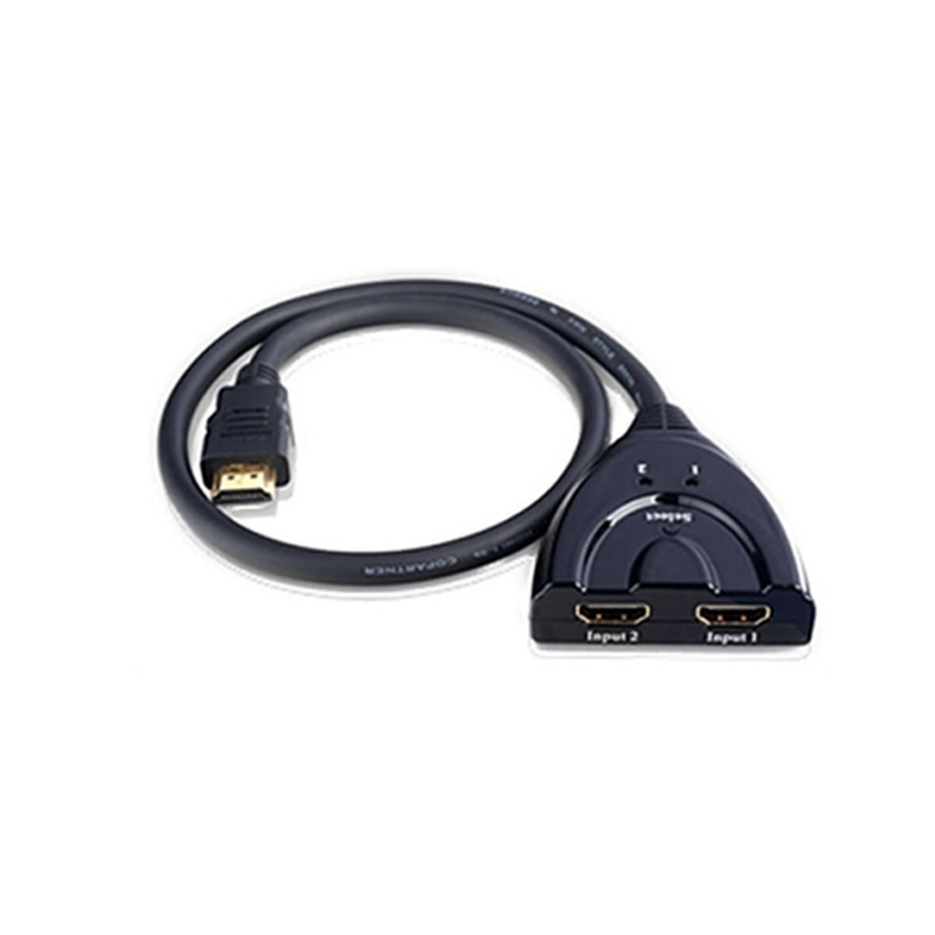

User Manual

Description
The Comprehensive CSW-HD201C 2x1/1x2 HDMI 4K Switcher allows you to connect two HDMI video sources to connect one HDMI display (2x1 configuration) or one HDMI source to two HDMI displays (1x2 configuration). The CSW-HD201C supports multiple resolutions from 480p @60Hz up to 4K @30Hz. The CSW-HD201C is widely compatible with HDTV, Blu-Ray DVD, PS4/5, Xbox 360 etc. Supports 12 bit deep color and comes with 24K Gold plated connectors. This low cost solution is a great add on when used in a digital signage system for a small store, a school or a government facility. The compact size allows the CSW-HD201C to be a quick portable solution when switching or splitting AV is required.

Features

- HDMI v1.4 & HDCP v1.4
- Transmission Bandwidth
- Supports manual & intelligent auto switching
- Supports max resolution 4K@30Hz
- Supports CEC
- No power source needed
- Build in fixed input HDMI cable
- Small form factor can be hidden away

Specifications
- Input: 2x HDMI (switcher mode), 1x HDMI (splitter mode)
- Output 1x HDMI (switcher mode), 2x HDMI (splitter mode)
- Supports HDMI version 1.4, 3D video, CEC, HDCP version 1.4
- Supported resolutions 4K/1080p/1080i,720p/720i/576p/576i/480p/480i
- Supported audio formats: DTS, DSD, Dolby AC 3 5.1 7.1 channels
- The highest sampling rate is 192KHz 24bit
- Input cable length: < 3m AWG 26 HDMI cable
- Output cable length: < 3m AWG 26 HDMI cable
- Supported bandwidth: 10.2Gbps
- Bi-Directional switching/splitting of AV signal sources and displays
- Compatible with MAC OS/Windows/Linux
- Product size: 60mmx56mmx17mm

Switcher mode (2 inputs & 1 output)
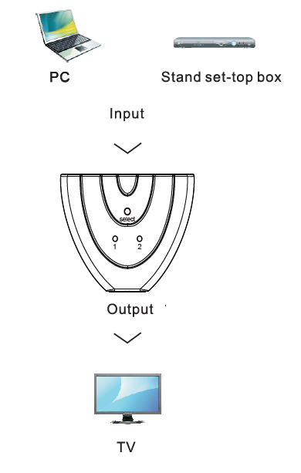

Splitter mode (1 input & 2 output)
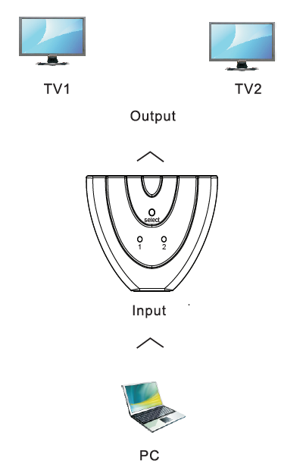
Note: TV 1 and TV 2 cannot be displayed simultaneously, only one display is allowed to function in this mode.

Packaging
- CSW-HD201C x1
- User manual x1


80 Little Falls Road, Fairfield, NJ 07004
sales@comprehensiveco.com l 800.526.0242 l www.ComprehensiveCo.com

